# **Appendix: R Code and Visualizations for House Price Prediction**

### **Mohit Maithani**

ALY 6040 - Data Mining  
Instructor: Justin Grosz

## **1. Introduction**

This appendix contains the **complete R code and visualizations** used for the analysis, exploration, and modeling of house prices in King County. The models include **Multiple Linear Regression, Decision Tree, and Random Forest**, and the visualizations support key findings in the main report. All figures are labeled for reference.

## **2. Load Required Libraries**

library(ggplot2)

library(dplyr)

library(corrplot)

library(rpart)

library(rpart.plot)

library(caret)

library(randomForest)

## **3. Load and Preprocess Data**

kc_data <- read.csv("kc_house_data.csv", stringsAsFactors = FALSE)

kc_data <- kc_data[!duplicated(kc_data$id), ] # Remove duplicates

kc_data$zipcode <- as.factor(kc_data$zipcode) # Convert Zipcode to Factor

kc_data$log_price <- log(kc_data$price) # Log Transformation of Price

## **4. Encode Zipcode into Clusters**

zipcode_median_price <- kc_data %>%

group_by(zipcode) %>%

summarize(median_price = median(price)) %>%

arrange(median_price)

zipcode_median_price$zipcode_cluster <- as.numeric(factor(zipcode_median_price$median_price,

levels = unique(zipcode_median_price$median_price)))

kc_data <- merge(kc_data, zipcode_median_price, by = "zipcode")

kc_data$zipcode <- NULL # Remove Original Zipcode Column

## **5. Train-Test Split**

set.seed(123)

trainIndex <- createDataPartition(kc_data$log_price, p = 0.8, list = FALSE)

train_data <- kc_data[trainIndex, ]

test_data <- kc_data[-trainIndex, ]

## **6. Exploratory Data Analysis (EDA) and Visualizations**

### **6.1 House Price Distribution (Before & After Log Transformation)**

ggplot(kc_data, aes(x = log_price)) +

geom_histogram(binwidth = 0.1, fill = "purple", color = "black", alpha = 0.7) +

labs(title = "Log-Transformed Price Distribution", x = "Log Price", y = "Count") +

theme_minimal()

*(See Figure 1: Log-Transformed Price Distribution)*

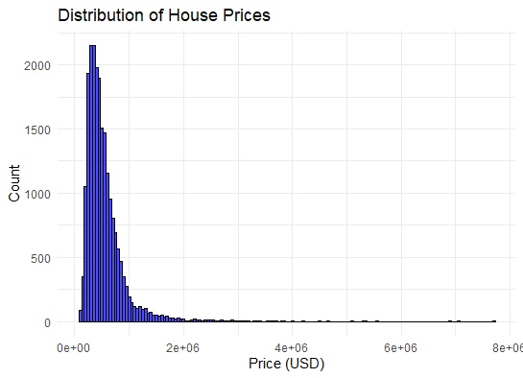

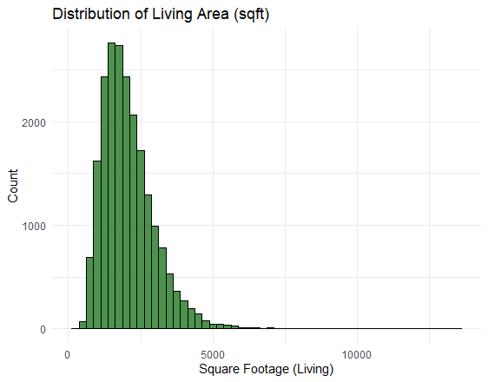

### **6.2 Scatter Plot: Sqft Living vs. Price**

ggplot(kc_data, aes(x = sqft_living, y = price)) +

geom_point(color = "darkblue", alpha = 0.5) +

geom_smooth(method = "lm", color = "red") +

labs(title = "Scatter Plot: Sqft Living vs. Price", x = "Living Area (sqft)", y = "Price (USD)") +

theme_minimal()

(See Figure 2: Scatter Plot - Sqft Living vs. Price)

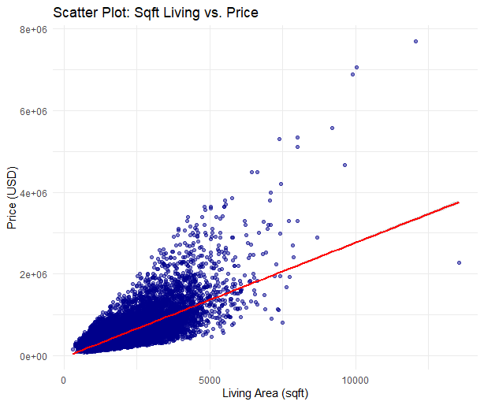

### **6.3 Seasonality Effects on House Prices**

library(lubridate)

# Convert Date Column to Proper Date Format

kc_data$date <- as.Date(kc_data$date, format="%Y%m%d")

# Extract Month and Year for Seasonality Analysis

kc_data$month <- month(kc_data$date, label = TRUE) # Month as Factor (Jan, Feb, etc.)

kc_data$year <- year(kc_data$date)

ggplot(kc_data, aes(x = month, y = price)) +

geom_boxplot(fill = "lightblue") +

labs(title = "Seasonality Effects: Monthly Price Distribution", x = "Month", y = "Price (USD)") +

theme_minimal()

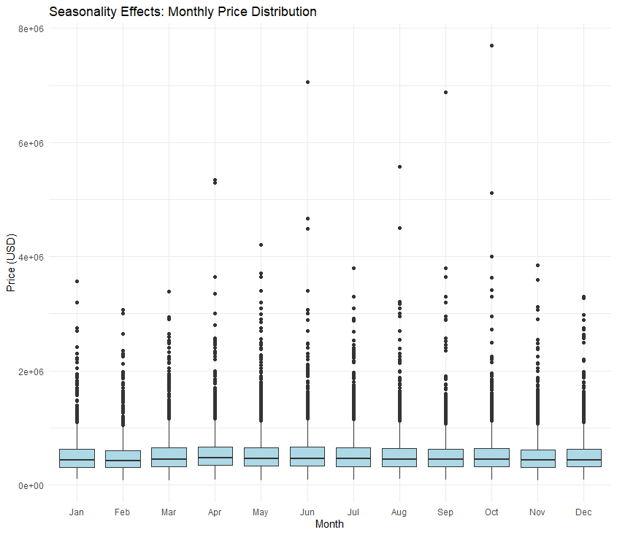

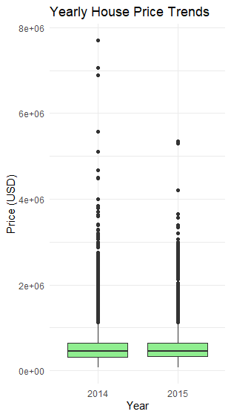

**Figure 8** → Yearly House Price Trends - Seasonality Effects

ggplot(kc_data, aes(x = factor(year), y = price)) +

geom_boxplot(fill = "lightgreen") +

labs(title = "Yearly House Price Trends", x = "Year", y = "Price (USD)") +

theme_minimal()

### 

### 

### 

### 

### **6.4 Correlation Heatmap of Key Variables**

cor_matrix <- cor(kc_data[, c("price", "sqft_living", "bedrooms", "bathrooms", "grade", "sqft_lot")])

corrplot(cor_matrix, method = "number", type = "upper",

title = "Correlation Heatmap of Key Variables", mar=c(0,0,1,0))

*(See Figure 3: Correlation Heatmap of Key Variables)*

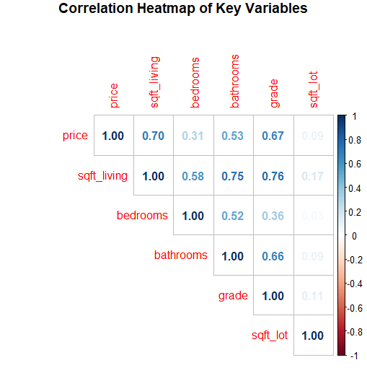

## **7. Multiple Linear Regression Model**

lm_model_zip <- lm(log_price ~ sqft_living + bedrooms + bathrooms + grade + zipcode_cluster, data = train_data)

summary(lm_model_zip)

predictions_log_lm_zip <- predict(lm_model_zip, newdata = test_data)

predictions_lm_zip <- exp(predictions_log_lm_zip)

*(See Figure 4: Regression Model Residual Analysis)*

## **8. Decision Tree Model**

tree_model_zip <- rpart(log_price ~ sqft_living + bedrooms + bathrooms + grade + zipcode_cluster, data = train_data, method = "anova")

rpart.plot(tree_model_zip, main = "Decision Tree for Predicting House Prices (With Zipcode Clusters)")

*(See Figure 5: Decision Tree Model Output)*

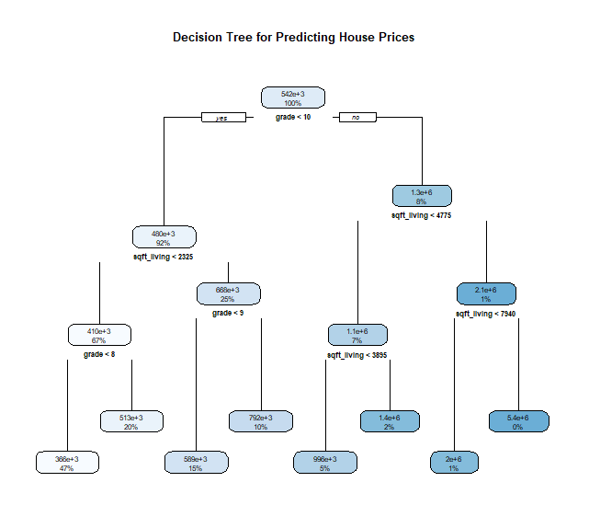

## **9. Random Forest Model**

rf_model_zip <- randomForest(log_price ~ sqft_living + bedrooms + bathrooms + grade + zipcode_cluster,

data = train_data, ntree = 500, importance = TRUE)

predictions_rf_zip <- predict(rf_model_zip, newdata = test_data)

predictions_rf_zip <- exp(predictions_rf_zip)

## **10. Feature Importance from Random Forest**

importance(rf_model_zip)

varImpPlot(rf_model_zip, main="Feature Importance in Random Forest Model (With Zipcode Clusters)")

*(See Figure 6: Feature Importance in Random Forest Model)*

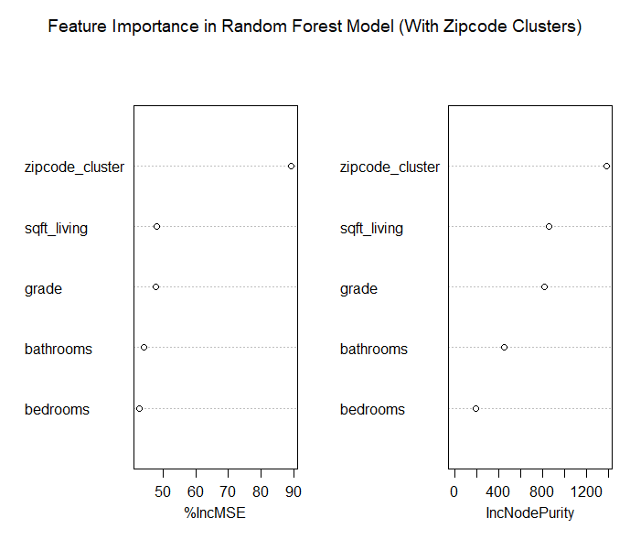

This appendix provides the **complete R code and visualizations** for the house price prediction project, covering **data preprocessing, EDA, and model training** using **Multiple Linear Regression, Decision Tree, and Random Forest models**.

All major visualizations, including **price distribution, correlation heatmap, scatter plots, decision tree structures, and feature importance plots**, are labeled accordingly. Please refer to the **figures referenced** for further insights.